IMPACT OF STORMS ON POPULATION HEALTH AND ECONOMY

DMK

6/19/2020

This report briefly examines the cumulative economic and polulation health impact of storms in the US from 1950 - 2007. The report examines data collected from the National Weather Services and utilizes “National Weather Service Instruction 10-1605” published on Aug. 17, 2007. Publication can be found via <https://www.nws.noaa.gov/directives> –> Operations & Services. Data can be found via <https://www.ncdc.noaa.gov/stormevents/ftp.jsp>.

knitr::opts_chunk$set(echo = TRUE)  
  
library(dplyr)

##   
## Attaching package: 'dplyr'

## The following objects are masked from 'package:stats':  
##   
## filter, lag

## The following objects are masked from 'package:base':  
##   
## intersect, setdiff, setequal, union

library(ggplot2)

knitr::opts_chunk$set(echo = TRUE)  
  
StormData <- read.csv("./StormData.csv", header = TRUE)

Adding columns with actual damage costs using representative letters in “…EXP”

knitr::opts_chunk$set(echo = TRUE)  
  
StormData$CROPCOST <- ifelse(StormData$CROPDMGEXP == "K", as.numeric(StormData$CROPDMG*1000), ifelse(StormData$CROPDMGEXP == "M", as.numeric(StormData$CROPDMG*1000000), ifelse(StormData$CROPDMGEXP == "B", as.numeric(StormData$CROPDMG*1000000000), "0")))  
  
StormData$PROPCOST <- ifelse(StormData$PROPDMGEXP == "K", as.numeric(StormData$PROPDMG*1000), ifelse(StormData$PROPDMGEXP == "M", as.numeric(StormData$PROPDMG*1000000), ifelse(StormData$PROPDMGEXP == "B", as.numeric(StormData$PROPDMG*1000000000), "0")))  
  
## Making sure data are numeric  
StormData <- transform(StormData, CROPCOST = as.numeric(CROPCOST), PROPCOST = as.numeric(PROPCOST))

Summarize data for easier viewing

knitr::opts_chunk$set(echo = TRUE)  
  
## Summary without State Codes  
SDSumm <- StormData %>% group_by(EVTYPE) %>% summarize("TotalCrop" = sum(CROPCOST), "TotalProp" = sum(PROPCOST), "Fatalities" = sum(FATALITIES), "Injuries" = sum(INJURIES))  
  
## Assumption: property & crop damage equal to economic cost, summarized in $ millions  
SDSumm$Econ_Millions <- as.numeric((SDSumm$TotalCrop + SDSumm$TotalProp)/1000000)  
  
## Assumption: fatalities and injuries equal to pop. health  
SDSumm$PH <- SDSumm$Fatalities + SDSumm$Injuries

As following chart of top-10 event types (ranked in descending order of total casualties) shows, flooding appears to have the highest impact on population health.

knitr::opts_chunk$set(echo = TRUE)  
  
## Descending sort on public health column  
SDSumm <- SDSumm[order(-SDSumm$PH),]  
  
## Chart creation  
chart <- ggplot(SDSumm[1:10,], aes(PH, reorder(EVTYPE, PH)))  
chart + geom_col() + xlab("Total Casualties (Fatalities + Injuries)") + ylab("Event Type") + ggtitle("CUMULATIVE PUBLIC HEALTH IMPACT (US)") + theme(axis.text.y = element_text(size = 8) + theme(axis.title = element_text(size = 8)))

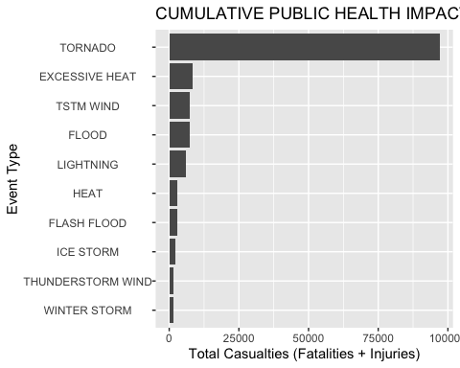

As following chart of top-10 event types (ranked in descending order of cost impact) shows, flooding appears to have the highest economic consequences.

knitr::opts_chunk$set(echo = TRUE)  
  
## Descending sort on public health column  
SDSumm <- SDSumm[order(-SDSumm$Econ_Millions),]  
  
## Chart creation  
chart2 <- ggplot(SDSumm[1:10,], aes(Econ_Millions, reorder(EVTYPE, Econ_Millions)))  
chart2 + geom_col() + xlab("Cost in Millions") + ylab("Event Type") + ggtitle("CUMULATIVE ECONOMIC IMPACT (US)") + theme(axis.text.y = element_text(size = 8) + theme(axis.title = element_text(size = 8)))

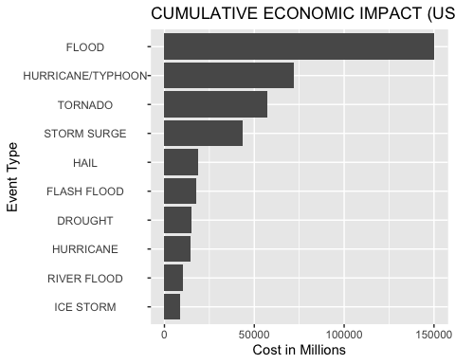

SUMMARY: Since 1950 (start date of data collection), highest economic costs from weather related events in the US have been due to flooding and highest public health impact (fatalities and injuries) have been due to tornadoes.